

**Placement Empowerment Program**

***Cloud Computing and DevOps Centre***

***Write a Python Script to Monitor an Application****: Create a Python script that sends periodic HTTP requests to your application and alerts you if it’s down.*

***Name: VIJAYA NANDANA M Department: CSE***

**Introduction**

This Proof of Concept (POC) demonstrates how to build a Python script that periodically checks the availability of an application by sending HTTP requests to its URL. It alerts the user if the application is down, helping to maintain consistent availability and reliability.

**Objectives**

* To develop a Python script that monitors the availability of an application by periodically checking its URL.
* To ensure the script alerts the user when the application is down or unreachable.
* To provide hands-on experience in using the requests library for HTTP requests in Python.
* To demonstrate how to implement basic error handling for network-related exceptions.
* To create a foundation for more advanced monitoring solutions, such as integrating notifications via email or messaging platforms.

**Step by Step Overview**

**1. Check for Python version**

Open Command Prompt on your Windows laptop. Type the following command and press Enter: ***python –version***

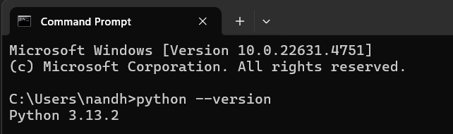

**2. Request install**

We need the requests library. In the same Command Prompt, type:

**pip install requests**

This will install the requests library needed to send HTTP requests.



### **3. Code Python**

Open Notepad and type the following code and Save the file as ***app_monitor.py*** on your Desktop.

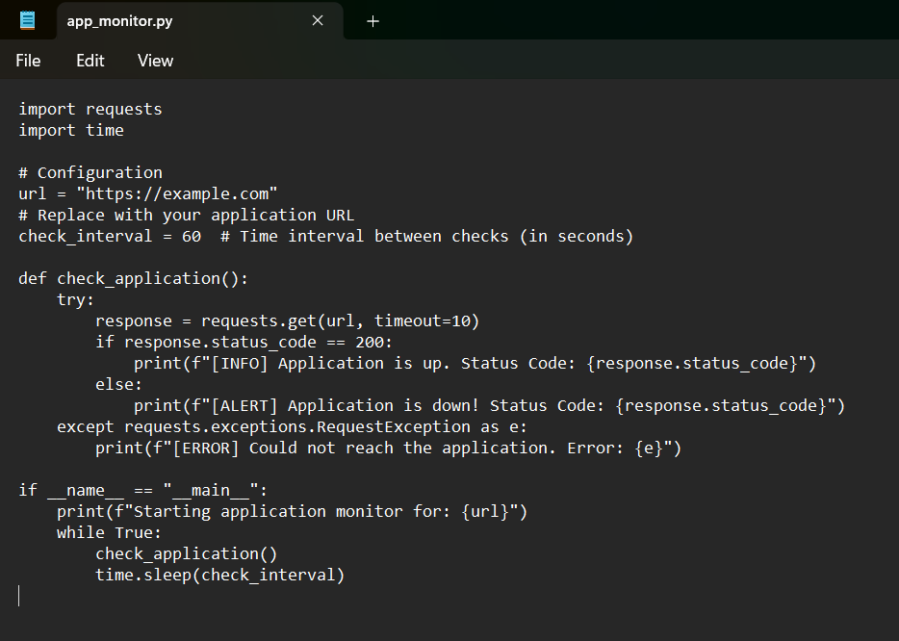

**4. Run the Code**

change the directory to your Desktop where you saved the scriptand run the python file.

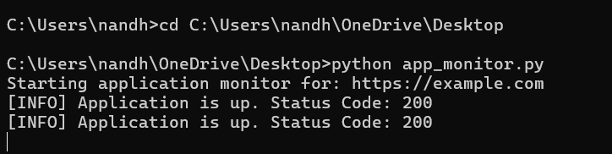

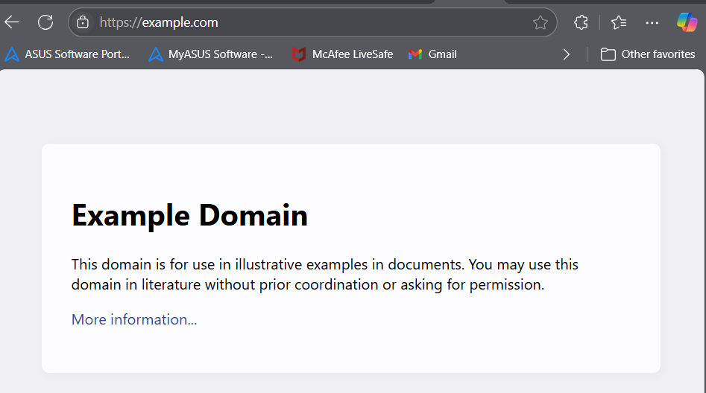

This means the script successfully checked https://example.com and found it online.

• Status Code: 200 indicates the website is reachable and working fine.

• The script will check the URL every 60 seconds.

To stop the monitoring, press Ctrl + C in the Command Prompt window.

**Outcome:**

* Develop a Python script that periodically sends HTTP requests to a specified URL to check the application's availability. Detect application downtime by analyzing HTTP status codes and receiving alerts if the application is down or unreachable.